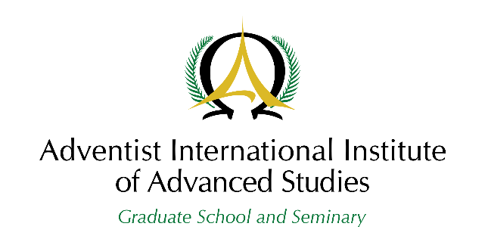
Graduate School
Education Department

Program Plan Rubric

Name of Student: __________________________________ Program: ______________________
Course: ______________________________ Academic Year and Term: ___________________

  A. CONTENT: The program/plan . . . | 30%
  is very comprehensive, accurate, timely, addresses thoroughly the question with depth of understanding, and integrates relevant theories, concepts, and principles. | 5
  is reasonably comprehensive and integrates some relevant theories, concepts, and principles. | 4
  is fairly comprehensive and integrates few relevant theories, concepts, and principles. | 3
  shows some basic understanding of the topic on a superficial level. | 2
  does not show basic understanding of the topic. | 1
  D. CHRISTIAN WORLDVIEW: The program/plan . . . | 10%
  integrates an excellent Christian worldview and follows a high moral standard. | 5
  integrates a good Christian worldview and follows a good moral standard. | 4
  integrates some Christian worldview and follows a good moral standard. | 3
  integrates limited Christian worldview. | 2
  integrates a very limited Christian worldview. | 1
  B. CRITICAL THINKING: The program/plan . . . | 20%
  displays clear, independent reasoning, supported with facts from multiple perspectives. Arguments are convincingly sustained. | 5
  displays sound and convincing reasoning but demonstrates some limitations in critical thinking. | 4
  is sound and convincing but a number of recurring critical thinking limitations are evident. | 3
  shows that critical thinking is somehow attempted, but is very limited. | 2
  does not show any evidence of critical thinking. | 1
  E. FEASIBILITY OF APPLICATION: The program/plan . . . | 10%
  demonstrates an excellent link between theory and practice, with a high probability of success in the chosen context. | 5
  proposes sound solutions that can work well. | 4
  provides some good ideas that can work well. | 3
  provides few good ideas that can work well. | 2
  shows no practical application. | 1
  C. ORGANIZATION OF IDEAS: The program/plan . . . | 10%
  shows that structure and order effectively highlight the key ideas and supporting details; the reader is able to move through the text easily. | 5
  shows that structure and order highlight the key ideas and supporting details: the reader is able to move through the text quite easily. | 4
  shows that the overall organization is fairly effective; some key ideas and supporting details are not properly placed. | 3
  shows that the overall organization is poor; the structure and order are not easily visible. | 2
  shows no logical structure. | 1
  F. LANGUAGE USAGE: The program/plan . . . | 10%
  uses correct English exceptionally well and follows the format and style of scholarly writing. | 5
  generally uses correct English and follows the format and style of scholarly writing but has some easily visible language usage issues. | 4
  uses good English and follows the format and style of scholarly writing but has some recurring language issues. | 3
  consistently shows issues in language usage and in the format and style of scholarly writing. | 2
  is hardly understandable due to recurring major language and formatting and style issues. | 1
G. LITERATURE: The program/plan . . . | 10%
is supported by a rich repertoire of credible* and recent literature from leading thought leaders and experts in the discipline. | 5
is supported by an adequate number of credible* and recent literature from leading thought leaders and experts in the discipline. | 4
is supported by an adequate number of literature, some of which are not credible* and recent. | 3
is supported by a limited number of literature. | 2
is supported by a very limited number of literature. | 1

*Credible as used in this rubric means trustworthy and cited accurately.

Total Score: /100

Comments:
______________________________________________________________________________
______________________________________________________________________________
______________________________________________________________________________
______________________________________________________________________________

Name of Professor __________________ Signature ____________ Date:

Program Plan Rubric
Approved by the Education Department on March 23, 2021

Adventist International Institute of Advanced Studies
Lalaan I, Silang, Cavite 4118, Philippines I Phone: 63 46 4144 300 I Email: scribe@aiias.edu
“Graduate Education with a Heart for Mission”

